Project Development Phase Model Performance Test

Date | 18 Fe bruary 2026
Team ID | LTVIP2026TMIDS24254
Project Name | Visualization Tool for Electric Vehicle Charge and Range Analysis
Maximum Marks

Model Performance Testing:
Project team shall fill the following information in model performance testing template.

S.No. | Parameter | Screenshot / Values
1. | Data Rendered | Cheapestelectriccars-EVDatabase : contains total eleven fields electric_vehicle_charging_station_list : contains total eight fields  ElectricCarData_Clean : contains total fourteen fields EVIndia : contains total ten fields
2. | Data  Preprocessing | The dataset is already clean and preprocessed. Only combining of all four datasets  are done in the data preprocessing phase.
3. | Utilization of Filters | 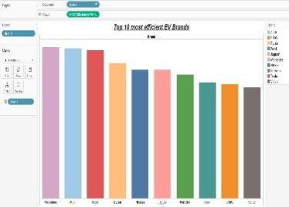  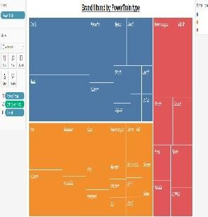  Brand filter is used for- Top 10 most efficient EV Brands
4. | Calculation fields Used

Power train filter is used for- Brand filtered by PowerTrain type Body style, Car brands in India,
Efficiency.
5. | Dashboard design | No of Visualizations / Graphs – A dashboard containing total eleven visualizations.
6 | Story Design | No of Visualizations / Graphs -Story design of all eleven visualizations created using the dataset.

